**Maven Installation**

Maven is distributed in several formats. The simplest way to install Maven is to download a ready-made binary distribution archive and follow the installation instructions. Maven 3.3+ release requires JDK 1.7 or above to execute. (Java 11 or higher recommended for this course)

#### **General Requirements**

* Java JDK must be installed on system.
* Java 1.7 is needed for Maven; Java 11 recommended for this course.

To verify the Java JDK is properly installed, from your command line run the following command:

jt$ javac --version

You should see:

javac 11

This command verifies the Java complier (javac) is installed. If javac is not found, check your Java JDK installation.

Maven will not function without a properly installed.

#### **Installing Maven on Windows 10**

1. To install Maven on Windows 10, ensure JAVA_HOME is set.

echo %JAVA_HOME%

Verify the above command returns a proper value. If nothing is returned, verify the Java JDK is installed on your system. JDK 1.7 is needed for the Maven. JDK 11 is recommended for the course

1. Download the binary zip archive from a [downloaded mirror](http://mirrors.wuchna.com/apachemirror/maven/maven-3/3.6.0/binaries/apache-maven-3.6.0-bin.zip).
2. Extract the archive to a suitable location.
3. Add the bin directory of the extracted Maven directory to the PATH environment variable. The steps to do so on Windows 10 is:
   1. Right-click **This PC** and select **Properties**.
   2. On the left pane, select **Advance system settings**.
   3. Click the **Environment Variables** button.
   4. In the **Environment Variables** dialog box that appears, double-click **Path** under **System variables**.

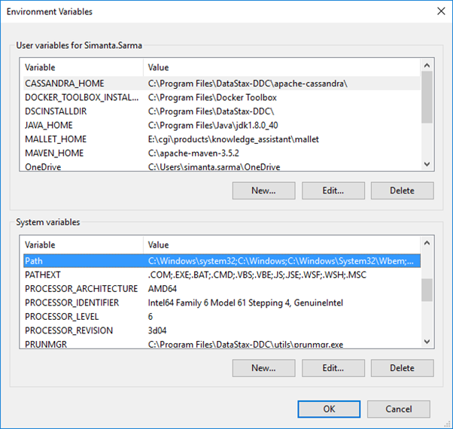

1. In the **Edit environment variable** dialog box that appears, click the **New** button.
2. Add the path to the bin directory of the Maven installation. An example path is C:\apache-maven-3.6.0\bin

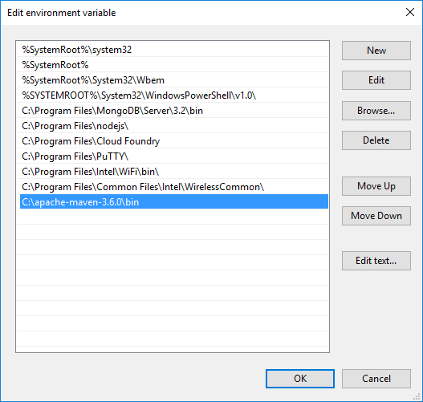

1. Click the **OK** button.
2. Click the **OK** button to close the **Environment Variables** dialog box.
3. Finally, click the **OK** button to close **System Properties**.
4. Open a new command prompt window and type the following command.

mvn -v

This command displays the version information. This also verifies that Maven is installed on your computer.

#### **Installing Maven on POSIX compatible Operating System (Linux and Mac OS X)**

To install Maven on a POSIX compatible Operating System, such as Linux or Mac OS X

1. Ensure JAVA_HOME is set.

echo $JAVA_HOME

1. Download the binary archive from a [download mirror](http://mirrors.estointernet.in/apache/maven/maven-3/3.6.0/binaries/apache-maven-3.6.0-bin.tar.gz).
2. Switch the Maven contents.

mv Downloads/apache-maven* /opt/apache-maven

1. Add Maven binaries to the PATH and append.

export PATH=/opt/apache-maven-3.6.0/bin:$PATH

1. Open a new terminal window and type this command.

mvn -v

This command displays the version information and verifies that Maven is installed on your computer.